z

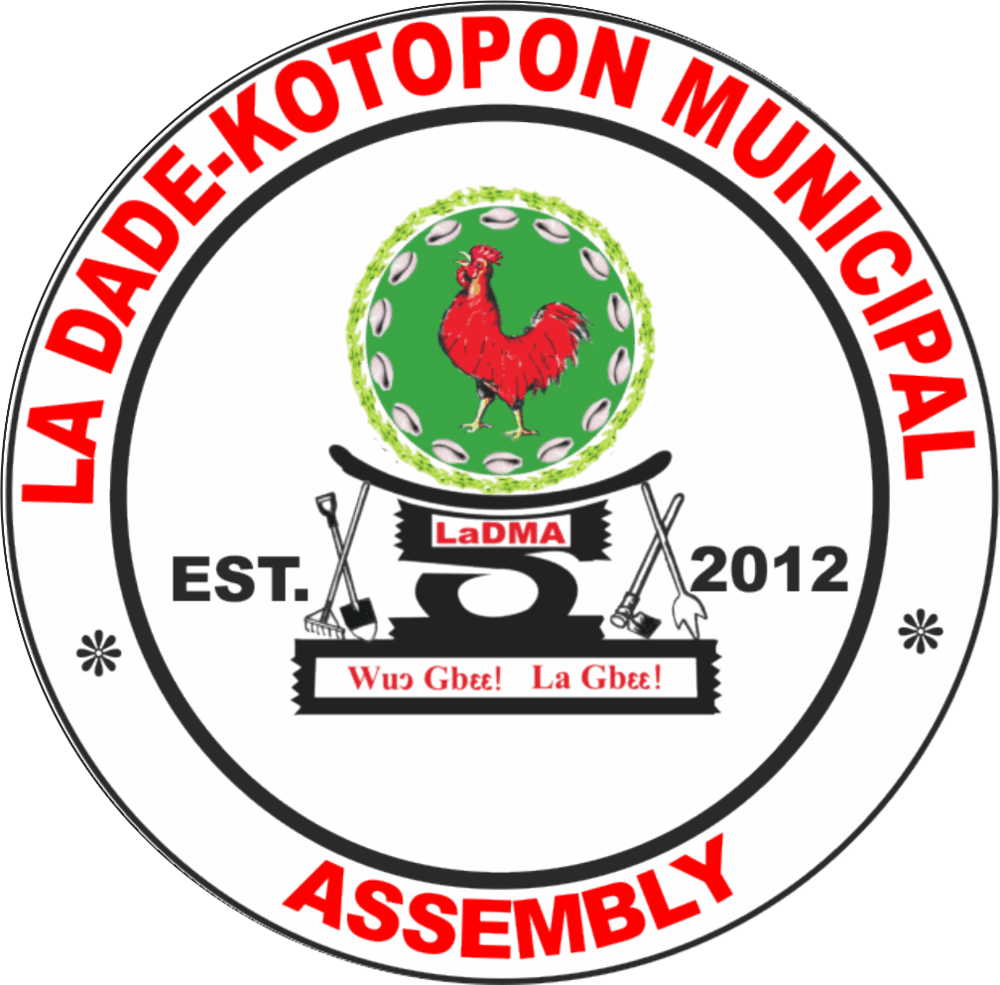

**Local Economic Development Plan 2022-2026**

**CHAPTER ONE**

**1.0 Introduction**

This chapter focuses on the performance of the Assembly in implementing programmes and

projects under the Agenda for Jobs, creating prosperity and equal opportunities for all’ between

2018 and 2021 as well as other interventions. It also presents a comprehensive description of

the current situation of the La Dade-Kotopon Municipality with their development implications

and an analysis of the Management Capacity in plan preparation and implementation. It ends

with a summary of the key development problems emanating from the situational analysis of

the profile.

**1.1 Vision, Mission, Functions and Core Values**

The Vision of the La-Dade-Kotopon Municipal Assembly (LaDMA) is, ‘To be the best administered Assembly which offers highly appreciable Development for its people’.

LaDMA’s Mission Statement is ‘La Dade-Kotopon Municipal Assembly exists to provide socio-economic development for the people within the Municipality, through effective mobilisation and deployment of fiscal, human, material and natural resources with stakeholders’ collaboration’.

The following are the Core Values of the Assembly; Teamwork, Excellence, Dedication, Discipline, Client Oriented and Timeliness. These are the values that have put the Assembly on top since its creation in 2012.

The Assembly derives its Functions from the Local Governance Act (2016), Act 936 and 940 as amended which maintains according to section 12 sub-section one that a District Assembly shall exercise political and administrative authority in the district; promote local economic development; and provide guidance, give direction to and supervise other administrative authorities in the district as may be prescribed by law. Hence a District Assembly shall exercise deliberative, legislative and executive functions (Republic of Ghana, 2016).

**CHAPTER TWO**

## **2.0 Economy of the Municipality (LED**)

According to the 2010 PHC, 43.6 percent of the population in the Municipality was economically active. Most of them are in wholesale and retail businesses with a negligible representation of the agricultural sector due to reduced arable lands. The Municipality has also been largely dominated by the “Informal Economy” due to rapid urbanization, massive unemployment and non-adherence to land-use planning.Currently, the indigenous areas of the Municipal enclave are dominated by makeshift structures such as kiosks, containers, sheds, canopies, mats, tables and chairs in open spaces and sometimes at junctions, smaller food vendor joints etc. Businesses spring up on a daily basis on pavements, streets and road reservations. Most of these service-oriented occupations range from dressmaking and other artisan related jobs and employ about 60 percent of the working population. The total number of businesses registered with the Assembly stands at 4,831.

Though Local Economic Development (LED) has more to do with using local resources by local enterprises to create jobs with an enabling environment by the public sector; MLGDRD (2013), one can conclude that unlike other rural assemblies with natural resources, LaDMA can only boast of the sea and the lagoon. These notwithstanding, the enabling environment to make businesses thrive is conducive in the Municipality, hence the establishment of the cane weaving industry in Cantonments with raw materials obtained from other sources.

There is high access to the financial services due to the presence of several banks in the Municipality. Utilities such as electricity, water, roads and telecommunication facilities also exist in the Municipality to facilitate job creation. Majority of the gainfully employed persons are into wholesaling, retailing, petty-trading, and repair of motor vehicles and motor cycles and other service-related jobs. Among potential investment areas are;

* Tourism
  + Development of the Beach Front
  + Kpeshie Lagoon Area
  + Hospitality industry
  + Homowo Festival
* Fishing Industry
* Turning urban waste into wealth
* ICT hub

La Dade-Kotopon is one of the richest Municipal Assemblies in Ghana. This was corroborated by a survey carried out in 2015, which revealed the Municipality as the least poor in the country making it a home to most former Presidents and Ministers. The Municipality has three major trading malls: Marina, Palace and Accra Mall. Figure 1.14 shows the major trading malls and markets in LaDMA.

**Figure 1.1 Market and Shopping Malls in LaDMA**

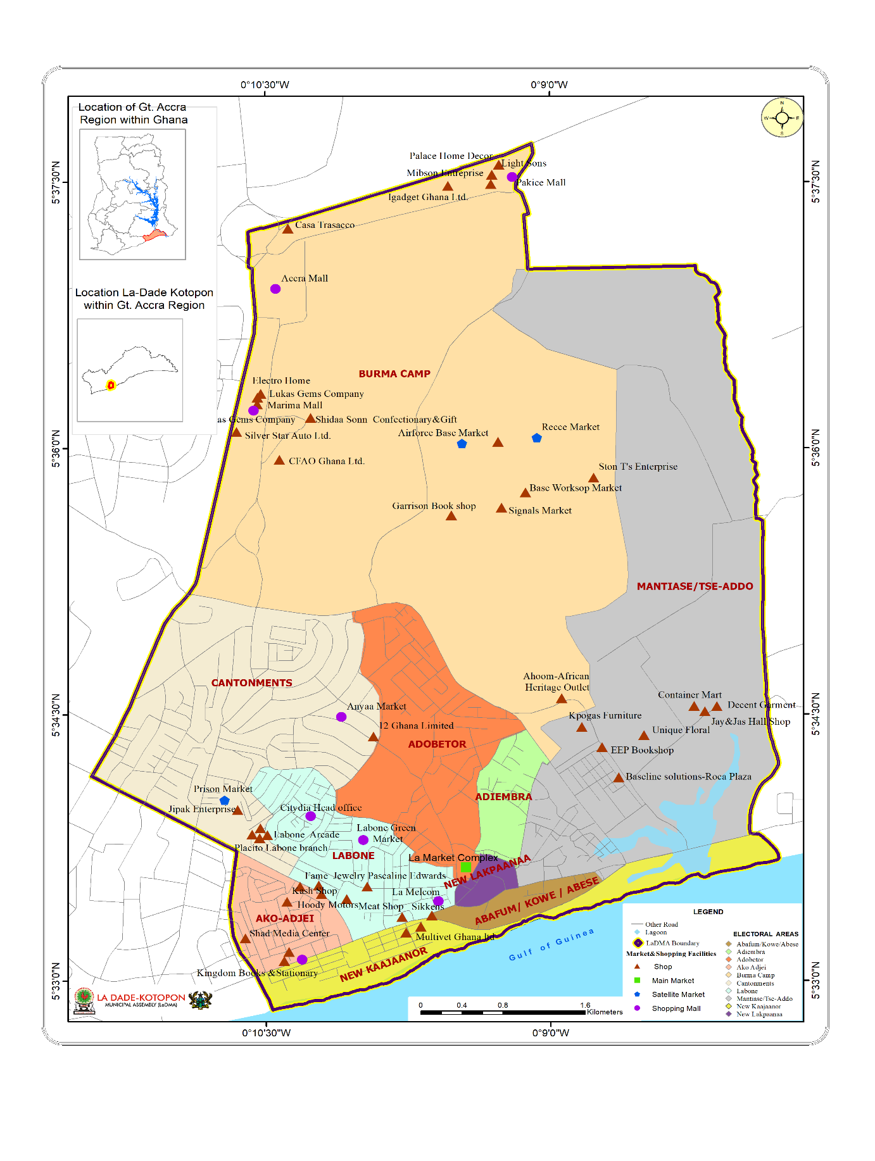

**Source: MI & LaDMA 2022**

**As part of the Government’s initiative to reduce unemployment, the Municipality engaged 1,036 unemployed youth in the Nation Builders Corp. Figure 1.15 shows the major occupations in LaDMA as captured in the PHC, 2010.**

Figure 1.2 Major Occupations in LaDMA

**Source: Adapted from the 2010 Population and Housing Census**

Currently, the Municipal Assembly plays host to some luxurious localities in the Greater Accra Metropolitan Area (GAMA). It hosts the Kotoka International Airport which has made the area one of the growth poles of the Region. Therefore, there is rapid emergence of businesses in motor vehicle, financial and hospitality industries especially in the Accra Airport City. Aside from security establishments, there is the dominance of International Diplomacies and Embassies is quite evident. With the existence of embassies such as the American, Australian, Chinese and Japanese and so forth, the Municipal enclave is not only open to prominent businessmen and women in Ghana but also exposed to the international community. Figure 1.16 shows the embassies and their location within the Municipality.

## **2.1 Tourism and Natural Resource Utilisation**

The growth of hospitality industries with other tourism related activities are the key areas of promoting tourism in the Municipality. The Municipality is blessed with natural resources such as the sea and the Kpeshie Lagoon. The coastal stretch has some hospitality industry facilities such as hotels, beaches, restaurants and clubs making the Municipality a great tourist destination. The Municipality hosts one of the prominent 5 stars and 4 stars hotels in the Ghana. The La Palm Royal Beach and Labadi Beach Hotels are among one of the unique hospitality industries in the Greater Accra Metropolitan Area.

Though most of the arable lands have been taken over by the construction of residential and other commercial structures, there are some vegetable farmers in the Municipality as well as fisher folks. Though, the Municipality does not have a forest, it plays host to a cane weaving industry in Cantonments.

During special occasions such as Easter, Christmas, Homowo Festival Celebrations, Independence Day Anniversary and Republic Day celebrations, most of these beaches are fully patronised. Again, there are visitors from the West African Sub-Region and other prominent Asian and European countries. It is worth mentioning that, the presence of the Kotoka International Airport makes the Municipality the gateway to the country.

The Municipality is also endowed with the rich festival which attracts foreign investors and the international community into the country. Most of these tourists are interested in the rich display of traditional culture amidst traditional dressing, dancing and drumming, the pouring of libation and the firing of musketry.

Efforts are also made to intensify public education on the awareness of Sexually Transmitted Diseases (STDs) such as HIV/AIDS. In some instances, the Health Directorate mounts “Public Health Stands” to distribute free condoms and guide the public on the importance of its usage. The Assembly aims at implementing sustainable tourism to conserve natural resources.

The Municipal District Command of the Ghana Police Service is also strengthened to tighten security. There are frequent patrols at nights and during the day to flash-out recalcitrant individuals who indulge in crime and rob tourists of their belongings and property. The Municipality’s challenge to tourism development includes maintaining high standards in sanitation.

## **2.2 Agriculture, Food Security and Nutrition**

Although agriculture is the backbone of the economy, only 3.1 percent of households in the Municipality are engaged in the activity. Majority of these farmers (70.2 percent) are involved in crop farming followed by livestock rearing; 24 percent. The scope embraces urban agriculture, home and school gardening in Labone SHS for income and improved nutrition as well as nutrition education.

The major crops grown are watermelons, maize, sweet potatoes, tomatoes, hot and bell peppers, onions and leafy vegetables. Also grown is okra - a spineless lady’s fingers variety indigenous to La. Within the livestock sub-sector, small and large ruminants, piggery, grass-cutter and poultry production are all undertaken across the municipality but in limited quantities. There are landing beaches for fish. Table 1.5 shows the staple crops and vegetables produced in the Municipality.

Whereas productivity per unit area has increased for some crops, the area available for agriculture has shrunk with farmers who are mostly free occupiers being pushed of the spaces they have been cultivating by land owners. In 2020; the estimated total land area under cultivation within the municipality was 85.8 hectors in Airport, Burma Camp, Tse-Addo, Aviation, parts of Labone and Cantonments. About 45 percent of agricultural land has been lost to the rapid construction of estate within the municipality.

As an intervention to counter the challenges of access to land for field cultivation, the Department is promoting intensive crop and livestock production. As such it has established the Agriculture Demonstration and Training Centre to train the youth and the general public on improved and modern technologies for various agricultural enterprises such as container vegetable production, greenhouse production, mushroom cultivation, aquaculture and drip irrigation for urban vegetable production.

**Summary of LED Issues**

| **Focus Areas** | **Issues** |
| --- | --- |
| * Private Sector Development | * Limited access to capital for businesses * Informal nature of businesses * Limited skills for business development |
| * Tourism development | * Inadequate development of tourism potentials |
| * Agriculture | * Low productivity of livestock and poultry products. * Limited land for farming * Inadequate market infrastructure |
| * Fisheries and Aquaculture development | * Low levels of private sector investment in aquaculture * Weak involvement of communities in fisheries resource management |

Goals, Focus Areas, Development Issues, Objectives and Strategies

| **Focus Areas** | **Development Issues** | | **Objectives** | **Strategies** |
| --- | --- | --- | --- | --- |
| **Goal: Build an Economically Viable Local Economy** | | | | |
| SMEs Development | | * Limited access to capital for businesses * Informal nature of businesses * Limited skills for business development | To support SMEs in business development | * Organize business management trainings (SDG Target 1.4,5) * Organise skills development training (SDG Target 8.3) * Mobilize resources from financial institutions to support SMEs (SDG Targets 8.10,9.3) (AU 1,4,5) |
| Tourism development | | * Inadequate development of tourism potentials | To diversify and expand the tourism industry for economic development | * Organise training for the youth in sustainable tourism and job creation (SDG Target 8.9, 12) * Mainstream tourism development in district development plans (SDG Target 8.97) |
| Agriculture | | * Inadequate market infrastructure | To provide modern market facilities | * Construct modern markets and retail infrastructure (SDG Target 2.3) (AU 4) |
| * Low productivity of livestock and poultry products. * Limited land for farming | To promote livestock and poultry development for food security and incomes | * Organise training for farmers on modern methods of farming (SDG Target 2.3, 2.4) |
| Fisheries and Aquaculture development | | * Low levels of private sector investment in aquaculture * weak involvement of communities in fisheries resource management | To sustainable develop and manage aquaculture and aquatic fisheries resources | * Provide adequate economic incentives to stimulate private sector investment in aquaculture development (SDG Targets 14.b) (AU 4,5) * Promote marine conservation and protection in a sustainable manner (SDG Targets 14.1,14.2,14.c) (AU 6,7) |

**Annual Action Plan for LED 2022**

|  |  |  |  |  |  |  |  |  |  |  |  |  |  |  |  |  |
| --- | --- | --- | --- | --- | --- | --- | --- | --- | --- | --- | --- | --- | --- | --- | --- | --- |
| No | Programme (PBB) | Sub-Programme (PBB) | Broad Activities | Location | Timeframe | | | | Cost | | | Program Status | | Implementing Institution/Dept. | | |
| 1 | 2 | 3 | 4 | GoG | IGF | Others | New | Ongoing | Lead | Collabo |
|  |  |  |  |  |  |  |  |  |  |  |  |  |  |  |  |
| TRADE INDUSTRY AND TOURISM SERVICES | | | | | | | | | | | | | | | | |
| 1. | Economic Dev’t | Trade, Indus. and Tourism Serv | Organise skills training and seminars for 200 women on small scale business management | Municipal Wide | x | x | x | x |  | 10,000 |  | x |  | SW&CD | GEA |
| 2. | Economic Dev’t | Trade, Indus. and Tourism Serv | Organize clients for business development, formalization and  standardization | Municipal wide | x | x | x | x |  | 33,400 |  | x |  | GEA | TI & TD |
| 3. | Economic Dev’t | Trade, Indus. and Tourism Serv | Mobilize, register and train 10 co- operative groups in financial management and conduct auditing | Municipal Wide | x | x | x | x |  | 30,000 |  | x |  | TI &TD | Central Admin |
| 4. | Economic Dev’t | Trade, Indus. and Tourism Serv | Support cultural activities to promote domestic tourism | Municipal Wide | x | x | x | x |  | 40,000 |  | x |  | TI &TD | Culture |
| 5. | Economic Dev’t | Trade, Indus. and Tourism Serv | Support the LED (1D1F, PERD, PFJ, RFJ | Municipal Wide | x | x | x | x |  | 27,000 |  | x |  | TI &TD | Central Admin |
| AGRICULTURE | | | | | | | | | | | | | | | | |
| 6. | Economic Dev’t | Agricultural Serv and Mgt | Educate & train FBOs in modern agro practices and Coop Business  Management | Municipal Wide | x | x | x | x |  | 17,000 | 73,947 | x |  | Agric Dept. | CIDA |
| 7. | Economic Dev’t | Agricultural Serv and Mgt | Train 70 Poultry Farmers in Disease Mgt Control & Value-  Chain Analysis | Municipal Wide | x | x | x | x |  | 17,832 |  | x |  | Agric Dept. | Central Admin |
| 8. | Economic Dev’t | Agricultural Serv and Mgt | Organize Farmers & Fishers’ Day celeb. | Trade Fair |  |  |  | x | 85,000 |  |  | x |  | Agric Dept. | Central Admin |
| 9. | Economic Dev’t | Agricultural Serv and Mgt | Vaccinate 1000 pets against rabies & 8000 birds against New Castle disease | Municipal Wide | x | x | x | x |  | 21,000 |  | x |  | Agric Dept. | Central Admin |
| FISHERIES | | | | | | | | | | | | | | | | |
| 10. | Economic Dev’t | Agricultural Serv and Mgt | Provide capacity development for 30 fishermen & 30 fish mongers in appropriate technologies and  management skills | Municipal Wide | x | x | x |  |  | 6,955 |  | x |  | Fisheries | Central Admin |
| 11. | Economic Dev’t | Agricultural Serv and Mgt | Provide training and awareness creation for 20 fish farmers on aquaculture management &  emerging market trends | Municipal Wide |  |  | x | x |  | 2,855 |  | x |  | Fisheries | Central Admin |

**Annual Action Plan for LED 2023**

|  |  |  |  |  |  |  |  |  |  |  |  |  |  |  |  |
| --- | --- | --- | --- | --- | --- | --- | --- | --- | --- | --- | --- | --- | --- | --- | --- |
| No | Programme (PBB) | Sub-Programme (PBB) | Broad Activities | Location | Timeframe | | | | Cost | | | Programme Status | | Implementing Institution/Dept. | |
| 1 | 2 | 3 | 4 | GoG | IGF | Others | New | Ongoing | Lead | Collabo |
| **TRADE INDUSTRY AND TOURISM SERVICES** | | | | | | | | | | | | | | | |
| 1. | Economic Dev’t | Trade, Indus. and Tourism Serv | Organise skills training and seminars for 200 women on small scale business management | Municipal Wide | x | x | x | x |  | 10,000 |  |  | x | SW&CD | GEA |
| 2. | Economic Dev’t | Trade, Indus. and Tourism Serv | Organise clients for business development, formalisation and  standardisation | Municipal wide | x | x | x | x |  | 33,400 |  |  | x | GEA | TI & TD |
| 3. | Economic Dev’t | Trade, Indus. and Tourism Serv | Mobilize, register and train 10 co- operative groups in financial management and conduct auditing | Municipal Wide | x | x | x | x |  | 30,000 |  |  | x | TI &TD | Central Admin |
| 4. | Economic Dev’t | Trade, Indus. and Tourism Serv | Support cultural activities to promote domestic tourism | Municipal Wide | x | x | x | x |  | 40,000 |  |  | x | TI &TD | Culture |
| 5. | Economic Dev’t | Trade, Indus. and Tourism Serv | Support the LED (1D1F, PERD, PFJ, RFJ | Municipal Wide | x | x | x | x |  | 27,000 |  |  | x | TI &TD | Central Admin |
| **AGRICULTURE** | | | | | | | | | | | | | | | |
| 6. | Economic Dev’t | Agricultural Serv and Mgt | Educate & train FBOs in modern agro practices and Coop Business  Management | Municipal Wide | x | x | x | x |  | 17,000 | 73,947 |  | x | Agric Dept. | CIDA |
| 7. | Economic Dev’t | Agricultural Serv and Mgt | Train 70 Poultry Farmers in Disease Mgt Control & Value-  Chain Analysis | Municipal Wide | x | x | x | x |  | 17,832 |  |  | x | Agric Dept. | Central Admin |
| 8. | Economic Dev’t | Agricultural Serv and Mgt | Organize Farmers & Fishers’ Day celeb. | Trade Fair |  |  |  | x | 85,000 |  |  |  | x | Agric Dept. | Central Admin |
| 9. | Economic Dev’t | Agricultural Serv and Mgt | Vaccinate 1000 pets against rabies & 8000 birds against New Castle disease | Municipal Wide | x | x | x | x |  | 21,000 |  |  | x | Agric Dept. | Central Admin |
| **FISHERIES** | | | | | | | | | | | | | | | |
| 10. | Economic Dev’t | Agricultural Serv and Mgt | Provide capacity development for 30 fishermen & 30 fish mongers in appropriate technologies and  management skills | Municipal Wide | x | x | x |  |  | 6,955 |  | x |  | Fisheries | Central Admin |
| 11. | Economic Dev’t | Agricultural Serv and Mgt | Provide training and awareness creation for 20 fish farmers on aquaculture management &  emerging market trends | Municipal Wide |  |  | x | x |  | 2,855 |  | x |  | Fisheries | Central Admin |

**ANNUAL ACTION PLAN 2024**

|  |  |  |  |  |  |  |  |  |  |  |  |  |  |  |  |
| --- | --- | --- | --- | --- | --- | --- | --- | --- | --- | --- | --- | --- | --- | --- | --- |
| No | Programme (PBB) | Sub-Programme (PBB) | Broad Activities | Location | Timeframe | | | | Cost | | | Programme Status | | Implementing Institution/Dept. | |
| 1 | 2 | 3 | 4 | GoG | IGF | Others | New | Ongoing | Lead | Collabo |
| **TRADE INDUSTRY AND TOURISM SERVICES** | | | | | | | | | | | | | | | |
| 1. | Economic Dev’t | Trade, Indus. and Tourism Serv | Organise skills training and seminars for 200 women on small scale business management | Municipal Wide | x | x | x | x |  | 10,000 |  |  | x | SW&CD | GEA |
| 2. | Economic Dev’t | Trade, Indus. and Tourism Serv | Organise clients for business development, formalisation and  standardisation | Municipal wide | x | x | x | x |  | 33,400 |  |  | x | GEA | TI & TD |
| 3. | Economic Dev’t | Trade, Indus. and Tourism Serv | Mobilize, register and train 10 co- operative groups in financial management and conduct auditing | Municipal Wide | x | x | x | x |  | 30,000 |  |  | x | TI &TD | Central Admin |
| 4. | Economic Dev’t | Trade, Indus. and Tourism Serv | Support cultural activities to promote domestic tourism | Municipal Wide | x | x | x | x |  | 40,000 |  |  | x | TI &TD | Culture |
| 5. | Economic Dev’t | Trade, Indus. and Tourism Serv | Support the LED (1D1F, PERD, PFJ, RFJ | Municipal Wide | x | x | x | x |  | 27,000 |  |  | x | TI &TD | Central Admin |
| **AGRICULTURE** | | | | | | | | | | | | | | | |
| 6. | Economic Dev’t | Agricultural Serv and Mgt | Educate & train FBOs in modern agro practices and Coop Business  Management | Municipal Wide | x | x | x | x |  | 17,000 | 73,947 |  | x | Agric Dept. | CIDA |
| 7. | Economic Dev’t | Agricultural Serv and Mgt | Train 70 Poultry Farmers in Disease Mgt Control & Value-  Chain Analysis | Municipal Wide | x | x | x | x |  | 17,832 |  |  | x | Agric Dept. | Central Admin |
| 8. | Economic Dev’t | Agricultural Serv and Mgt | Organize Farmers & Fishers’ Day celeb. | Trade Fair |  |  |  | x | 85,000 |  |  |  | x | Agric Dept. | Central Admin |
| 9. | Economic Dev’t | Agricultural Serv and Mgt | Vaccinate 1000 pets against rabies & 8000 birds against New Castle disease | Municipal Wide | x | x | x | x |  | 21,000 |  |  | x | Agric Dept. | Central Admin |
| **FISHERIES** | | | | | | | | | | | | | | | |
| 10. | Economic Dev’t | Agricultural Serv and Mgt | Provide capacity development for 30 fishermen & 30 fish mongers in appropriate technologies and  management skills | Municipal Wide | x | x | x |  |  | 6,955 |  | x |  | Fisheries | Central Admin |
| 11. | Economic Dev’t | Agricultural Serv and Mgt | Provide training and awareness creation for 20 fish farmers on aquaculture management &  emerging market trends | Municipal Wide |  |  | x | x |  | 2,855 |  | x |  | Fisheries | Central Admin |

**Annual Action Pan 2025**

|  |  |  |  |  |  |  |  |  |  |  |  |  |  |  |  |
| --- | --- | --- | --- | --- | --- | --- | --- | --- | --- | --- | --- | --- | --- | --- | --- |
| No | Programme (PBB) | Sub-Programme (PBB) | Broad Activities | Location | Timeframe | | | | Cost | | | Programme Status | | Implementing Institution/Dept. | |
| 1 | 2 | 3 | 4 | GoG | IGF | Others | New | Ongoing | Lead | Collabo |
| 1. | Economic Dev’t | Trade, Indus. and Tourism Serv | Organise skills training and seminars for 200 women on small scale business management | Municipal Wide | x | x | x | x |  | 10,000 |  |  | x | SW&CD | GEA |
| 2. | Economic Dev’t | Trade, Indus. and Tourism Serv | Organise clients for business development, formalisation and  standardisation | Municipal wide | x | x | x | x |  | 33,400 |  |  | x | GEA | TI & TD |
| 3. | Economic Dev’t | Trade, Indus. and Tourism Serv | Mobilize, register and train 10 co- operative groups in financial management and conduct auditing | Municipal Wide | x | x | x | x |  | 30,000 |  |  | x | TI &TD | Central Admin |
| 4. | Economic Dev’t | Trade, Indus. and Tourism Serv | Support cultural activities to promote domestic tourism | Municipal Wide | x | x | x | x |  | 40,000 |  |  | x | TI &TD | Culture |
| 5. | Economic Dev’t | Trade, Indus. and Tourism Serv | Support the LED (1D1F, PERD, PFJ, RFJ | Municipal Wide | x | x | x | x |  | 27,000 |  |  | x | TI &TD | Central Admin |
| 6. | Economic Dev’t | Agricultural Serv and Mgt | Educate & train FBOs in modern agro practices and Coop Business  Management | Municipal Wide | x | x | x | x |  | 17,000 | 73,947 |  | x | Agric Dept. | CIDA |
| 7. | Economic Dev’t | Agricultural Serv and Mgt | Construct a market with landscaping | Tse-Addo | x | x | x | x |  | 400,000 |  | x |  | Agric Dept. | Central Admin |
| 8. | Economic Dev’t | Agricultural Serv and Mgt | Train 70 Poultry Farmers in Disease Mgt Control & Value- Chain Analysis | Municipal Wide | x | x | x | x |  | 17,832 |  |  | x | Agric Dept. | Central Admin |
| 9. | Economic Dev’t | Agricultural Serv and Mgt | Organize Farmers & Fishers’ Day celeb. | Trade Fair |  |  |  | x | 85,000 |  |  |  | x | Agric Dept. | Central Admin |
| 10. | Economic Dev’t | Agricultural Serv and Mgt | Vaccinate 1000 pets against rabies & 8000 birds against New Castle disease | Municipal Wide | x | x | x | x |  | 21,000 |  |  | x | Agric Dept. | Central Admin |
| 11. | Economic Dev’t | Agricultural Serv and Mgt | Provide capacity development for 30 fishermen & 30 fish mongers in appropriate technologies and  management skills | Municipal Wide | x | x | x |  |  | 6,955 |  | x |  | Fisheries | Central Admin |
| 12. | Economic Dev’t | Agricultural Serv and Mgt | Provide training and awareness creation for 20 fish farmers on aquaculture management & emerging market trends | Municipal Wide |  |  | x | x |  | 2,855 |  | x |  | Fisheries | Central Admin |

**REFERENCES**

GSS. (2014). *2010 Population and Housing Census. District Analytical Report. La Dade-Kotopon*

*Municipal . Accra: Ghana Statistical Service.*

LGS. (2016). *Framework for Participatory Planning and Budgeting. Accra: Local*

*Government Service.*

LGSS. (2014*). Mnanual for Social Accountability. Accra: Local Government Service*

*Secretariat.*

MLGRD. (2012). *National Urban Policy Framework and Action Plan. Accra: Ministry of*

*Local Government and Rural Development.*

MLGRD. (2013). *National Local Economic Development Policy. Accra: Ministry of Local*

*Government and Rural Development*

**ASSENT TO ACCEPTANCE OF THE LED PLAN FOR 2022- 2026:**

**Signatures of:**

**HON. SOLOMON NIKOI KOTEY**

**MUNICIPAL CHIEF EXECUTIVE ………………………………………………….**

**DANIEL NKRUMAH**

**MUNICIPAL COORDINATING DIRECTOR ………………………………………………….**

**SAMUEL SETH AHOMKA SEY**

**MUNICIPAL PLANNING OFFICE ……………………………………………….**